Flyer July 2019-06-19
Half a million. Or, precisely 501, 389. That is how many coho salmon Fanny Bay Salmon Enhancement Society volunteers have rescued from drying creeks and shrinking pools over the last 22 years. That number is actually higher now, by 20,587, because we are again in the middle of salvage season, when the boys and girls of the FBSES plunge into the creeks— actually the gravel that is the bed of the creeks—and bring out buckets of fish. On June 20, those 20,587 happy little swimmers were going around in circles in our Berray Road tanks, not far from the Cook, Hart-Washer and Rosewall creeks they were plucked from. Salvage is necessary in some streams but not in others like Wilfred or Waterloo or the Tsable river that have more dependable sources and larger watersheds. It is especially vital in dry springs and summers when water disappears into stream beds of even the larger creeks of our area, like Rosewall. Salvage season follows closely and sometimes overlaps counting box season, which is when our three traps gather all the aquatic life that tries to move past them and hold them for identification and counting. Coho smolts are our main interest because these are the wild fish that will be leaving the streams to mature in the Pacific and, we hope, return to the same stream to spawn. If they dawdle, they and the fry just starting their year may be the ones we trap, scoop or dip out of a dangerously small trickle. Because smolts (one and one-half year olds) are bound for salt water they are usually released where we find water close to the tidal zones: fry get to stay with us until they smolt and then they’re outa here with a head start.
The world of a small stream on the east coast of Vancouver Island is populated with a variety of creatures, and they all get called by name and numbered, then released to go about their business. That business is to eat, if you’re a 9 inch trout, or try not to be eaten if you’re one of the six coho smolts or five stickleback that were in the box with him on a sunny April 9 when the air temperature was seven degrees and the water temperature five and that water depth was .43 meters. All of that is learned from one line of data entered in the box log book by Rosemary Sparham on her visit to the Cook Creek box that day. The Cook Creek box was installed in its place March 27 and pulled out May 31 after a counting season plagued by beaver who continually plugged, obstructed and frustrated the pipe leading to the box and thence to the creek. Beaver want their ponds still and tight, fish need a way out to the stream and ocean. Caught in the middle are FBSES volunteers who need to see fish in their counting boxes and don’t want to destroy any life forms, even aggravating ones who should stay on the nickel or in their dens. Still, 570 coho smolts reared in the Cook Creek Relic Ponds site made it past all obstacles, but mainly mud and sticks, to pause on their way to maturity in the counting box. 831 were counted in 2018, a year the beaver took off.
Wilfred Creek’s numbers aren’t as high as Mud Bay Creeks’ even though it’s a much more impressive waterway. But it is consistent with the other two traps in the surge of departures of coho to the saltchuck; in early to mid-May the numbers in every box jump as each fish checks its internal calendar and decides it is leaving home. Bill and Alaine French counted the largest number of2019 transient coho on May 9 with 116, the next day, only four. In 2018 the bulge came later: 106 on the 14th, 145 on the 15th,126 on May 16—goodbye Wilfred, hello Strait of Georgia.
On Mud Bay Creek, a gratifying 1494 coho smolts got enumerated in 2019, but that compares to 2185 in 2018, the kind of fluctuations nature throws at us all the time. We always have time for you Wednesday and Saturday mornings at 8425 Berray Road and the website is always there at www.fbses.ca
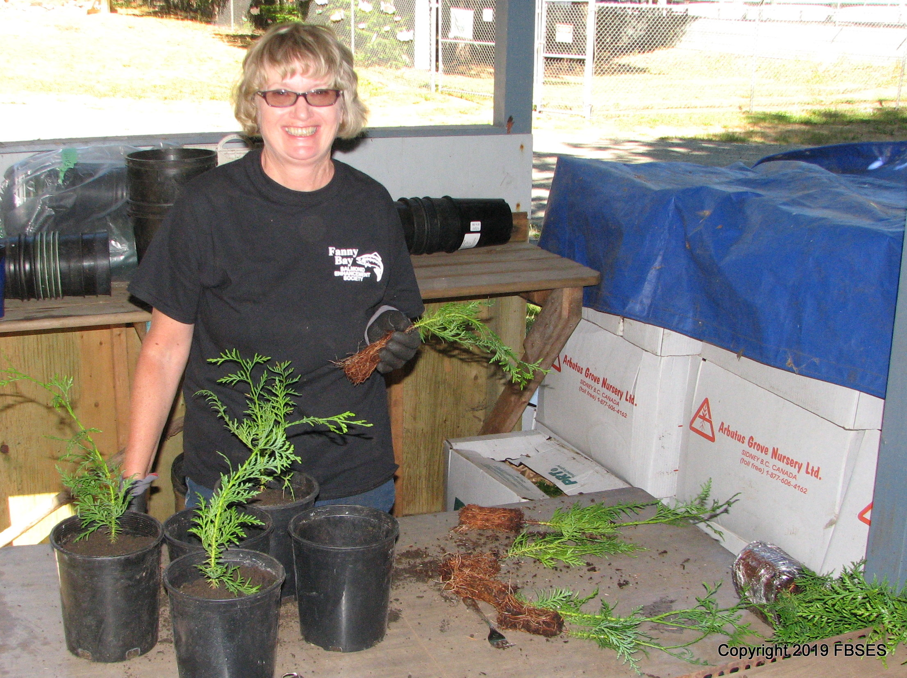

Photo caption: FBSES volunteer Lorraine Gardner of Vivian Way enjoys the challenge of potting cedars. A good thing, because those boxes are full of them.

